# **PART 6 TOKEN PLAN**

**6.1 REC Token**

The token name of Our Token is **REC**. REC is a ERC20 Token. The total amount of REC tokens is fixed.

**6.2 Token Sale Overview**

The RecTeam Token Sale will take place on August 1st 2018 9:00 LONDON Time and will conclude not the earlier than (1) Sep 30th 2018 23:59 LONDON Time (the“Closing Date”); or (ii) until the amount of contributions received reaches our sale target. Provided that RecTeam may extend the Closing Date, in its sole discretion, with each extension being 30 days (the “Token Sale End Date”).

**Token Name: REC**

**The total amount of REC tokens: 1,000,000,000 (1 Billion)**

**The Max ICO Sale (Hard Cap): 200 Million REC**

All unsold REC token during this ICO period will be saved in the Reserve for the Loan Service.

The minimum purchase amount shall be 0.1 ETH / 800 REC Tokens

**1 ETH = 8, 000 REC**

The exact number of REC Tokens to be received by a contributor will depend on what day and amount of the Token Sale the contribution is made. (Note, we want to give different base price every 2 week, for example 1 August- 14 August, 1 ETH = 10000,

15 August – 28 August, 1 ETH = 9500, ect)

**Bonus for Large Purchasers**

**5 ETH per purchase transaction, can get 5% Bonus**

**10 ETH per purchase transaction, can get 10% Bonus**

**15 ETH per purchase transaction, can set 15% Bonus**

**20 ETH or more per purchase transaction, can get 20% Bonus**

To participate in the Token Sale, token buyers will pay in ETH:

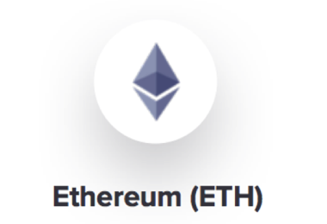

The tokens will be delivered to the participants of the Token Sale after the Token Sale End Date. Transferability of the tokens is governed by the applicable vesting period, if any.

The breakdown of token allocation is as follows:

• 20% of REC tokens to be allocated to the Token Sale;

• 10% of REC tokens to be created will be distributed to founders and employees;

• 10% of REC tokens to be allocated to the bounty program and partners;

• 60% of REC tokens to be created will be part of the RECT Reserve and will be retained by RecTeam for the loan service and future sale, as described below;

RecTeam is committed to a transparent token sale process and RecTeam will not create any new REC tokens after the Token Sale.

**Vesting**

The vesting schedule for each participating group is as follows:

* Large Volume Purchasers (i.e., those who purchase REC tokens valued a total of 3,000 ETH or more in a single transaction): 6 months vesting period, 16.67% vesting each month;
* RecTeam Employees: 3 years, linear vesting.

**6.3 RecTeam Reserve**

As described above, RecTeam will use the REC tokens in the RecTeam Reserve for RecTeam loan service, The RecTeam Reserve may not be intentionally distributed to employees.

RecTeam will use 35% of its annual profit to purchase the REC token from the market. These REC tokens will be used in the loan service of RecTeam, it will promote the circulation of the REC token and business expansion of RecTeam.